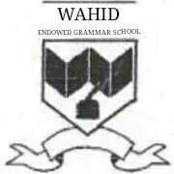

**WAHID ENDOWED GRAMMAR SCHOOL ‘O’ LEVEL**

**Affiliated with the University of Cambridge, England (Registered)**

**NAME __________________**

**REINFORCEMENT WORKSHEET FOR THE FINAL SESSION 2023 – 24**

**NURSERY**

**MATHS**

**DURATION: 20TH MAY 2024 TO 31ST MAY 2024**